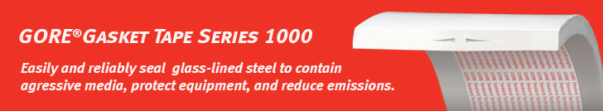

Dear customer,

Are you looking for a gasket tape that is used by chemical processers to deal with aggressive media under demanding conditions?

[GORE Gasket Tape Series 1000](https://www.gore.com/products/gore-gasket-tape-series-1000) addresses all the challenges of reliably sealing large glass-lined-steel flanges.

* Typical applications: columns, mixer vessels, reactors, storage and receiver tanks
* Made of 100% expanded PTFE (ePTFE), this highly conformable tape is chemically inert, and highly resistant to creep, cold flow and clamp-force loss.
* Reliable and long-term: provides chemical protection across the full flange width, enables longer maintenance cycles, as demanded by leading chemical producers
* Optimal form for easy handling: gasket can be customized on-site, no fabrication lead-time required, simplifies and speeds handling & transport, adhesive backing enables easy installation, faster, less complicated shimming tape technique for larger deviations, reduces inventory costs
* Outstanding conformability to deviations: seals deviations even at low gasket stress, easily passes the bubble test, for trouble-free mechanical completion (MC) or start-up

Learn more about this product on Gore’s website:

* [Product overview](https://www.gore.com/products/gore-gasket-tape-series-1000)
* [Datasheet](https://www.gore.com/resources/data-sheet-gore-gasket-tape-series-1000)
* [Video](https://www.youtube.com/watch?v=E5OEsgJn6TA)
* [Installation guide](https://www.gore.com/resources/video-gore-gasket-tape-series-1000-installation-video)
* [Certificates](https://www.gore.com/resources/search?f%5b%5d=product:211&f%5b%5d=content_type:336&f%5b%5d=language:en)

Please feel free to reach out to (contact name) at (contact phone number) or (contact email) if you have an application for which you would like to explore the use of this form-in-place gasket material.

Sincerely,

(Distributor Name)

(Signature Distributor)

