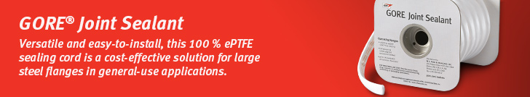

Dear customer,

Are you looking for a time-tested sealing solution for steel flanges with large diameters, rectangular or irregular shapes, and rough or pitted surfaces?

Versatile [GORE Joint Sealant](https://www.gore.com/products/gore-joint-sealant) is standard sealing material for many MRO (Maintenance, Repair and Operations) teams because it seals reliably – and because it is easy and cost-effective to install.

* Typical applications: Tank manways, ductwork, housing covers
* Made of 100% monoaxially expanded PTFE (ePTFE), using Gore’s expansion technology to create a high degree of fibrillation.
* High fibrillation is what improves strength and seal performance, and creates the soft, conformable surface that readily fills minor flange irregularities.
* Simplicity and cost reductions: It adheres readily, and forms a gasket when the ends are overlapped – so even sealing vertical flanges is a one-person job. Its tight, durable seal means maintenance is minimal, too. With fewer interruptions and less downtime, productivity is higher all around – and so are the related cost savings.

Learn more about this product on Gore’s website:

* [Product overview](https://www.gore.com/products/gore-joint-sealant)
* [Datasheet](https://www.gore.com/resources/data-sheet-gore-joint-sealant)
* [Installation guide](https://www.gore.com/resources/installation-guide-gore-joint-sealant)
* [Certificates](https://www.gore.com/resources/search?f%5b%5d=product:201&f%5b%5d=content_type:336&f%5b%5d=language:en)

Please feel free to reach out to (contact name) at (contact phone number) or (contact email) if you have an application for which you would like to explore the use of this form-in-place gasket material.

Sincerely,

(Distributor Name)

(Signature Distributor)

