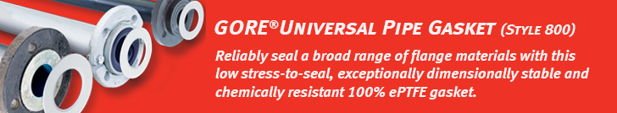

Dear customer,

Are you looking for a single gasket solution, which can reduce the process safety and production downtime risks caused by the use of an incorrect gasket material?

[GORE Universal Pipe Gasket (Style 800)](https://www.gore.com/products/gore-universal-pipe-gasket-style-800) provides a reliable seal in the full spectrum of strong acid, alkali, and solvent process media, including the most challenging thermal cycling and elevated temperature applications.

* Typical applications: Steel, Technical Enamel (Glass-lined Steel) and Fiber Reinforced Plastic (FRP) flanges
* Uniquely combines two patented construction elements, each made of 100% expanded PTFE (ePTFE).
* Long-term reliable sealing: with superior resistance to creep and cold flow, GORE Universal Pipe Gasket (Style 800) retains its dimensional stability through thermal and pressure cycles. Bolt load is maintained, to achieve a long-term reliable seal.
* One gasket, many applications: creates a tight, reliable seal for multiple flange materials, so it can replace multiple other gasketing materials.

Learn more about this product on Gore’s website:

* [Product overview](https://www.gore.com/products/gore-universal-pipe-gasket-style-800)
* [Datasheet](https://www.gore.com/resources/data-sheet-gore-universal-pipe-gasket-style-800)
* [Installation guide](https://www.gore.com/resources/installation-guide-gore-universal-pipe-gasket-style-800)
* [Certificates](https://www.gore.com/resources/search?f%5b%5d=product:136&f%5b%5d=content_type:336&f%5b%5d=language:en)

Please feel free to reach out to (contact name) at (contact phone number) or (contact email) if you have an application for which you would like to explore the use of this single gasket solution.

Sincerely,

(Distributor Name)

(Signature Distributor)

