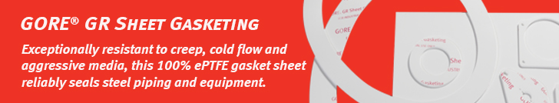

Dear customer,

Are you looking for a sheet gasketing which is designed to outperform both conventional (filled and skived) PTFE and other ePTFE gasketing in steel piping and equipment?

[GORE GR Sheet Gasketing](https://www.gore.com/products/gore-gr-sheet-gasketing) is a versatile, single-solution material for both standard and custom gasketing shapes and sizes.

* Typical applications: steel pipe and equipment flanges requiring standard or complex gasketing shapes and sizes.
* Made of specially-engineered 100% expanded PTFE (ePTFE), Gore's patented manufacturing technology creates an ePTFE sheet with the highest degree of expansion available.
* Superior resistance to creep and cold flow: greater tensile strength, so it retains greater dimensional stability in-use — in both thickness and width — than any other PTFE-based gasket, including any other ePTFE
* Greater consistency, for fewer problems: consistency and precision of Gore manufacturing processes give GORE GR Sheet Gasketing a much more uniform distribution of mass, this promotes a more uniform and reliable seal.

Learn more about this product on Gore’s website:

* [Product overview](https://www.gore.com/products/gore-gr-sheet-gasketing)
* [Datasheet](https://www.gore.com/resources/data-sheet-gore-gr-sheet-gasketing)
* [Installation guide](https://www.gore.com/resources/installation-guide-gore-gr-sheet-gasketing)
* [Certificates](https://www.gore.com/resources/search?f%5b%5d=product:361&f%5b%5d=content_type:336&f%5b%5d=language:en)

Please feel free to reach out to (contact name) at (contact phone number) or (contact email) if you have an application for which you would like to explore the use of this sheet and cut gasket material.

Sincerely,

(Distributor Name)

(Signature Distributor)

